COLKIRK PARISH COUNCIL
Chairman: Cllr. C Joice Clerk: Maxine Hayes
______________________________________________________________

TO ALL ELECTORS OF THE PARISH OF COLKIRK
NOTICE OF THE ANNUAL PARISH MEETING TO BE HELD ON WEDNESDAY 6TH MAY 2026 AT 7.30PM IN THE JIM HALL ROOM, VILLAGE HALL.

Yours sincerely

Maxine Hayes

Clerk to the Council
28th April 2026

AGENDA

- To receive apologies for absence

- To confirm the minutes of the Annual Parish Meeting held on 7th May 2025

- To receive the Chairmans report for the year

- To receive a report from the Colkirk Charities Accounts

- To receive a report from The Friends of Colkirk Village

- To receive a report from the Parish Council

- To receive any reports from the County and District Councillors

- Open Public Forum
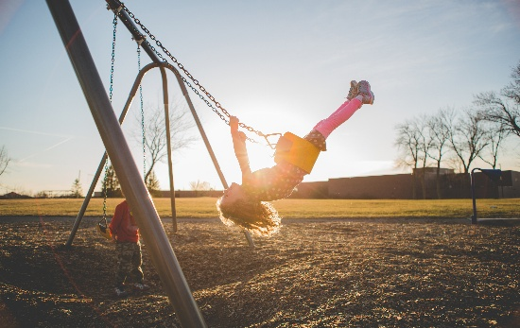
draft versions of the proposed replacement play equipment will be on display. Please come along to view them and share your feedback

